**Fanka Shundovska**

**IntelliJ – JAVA Homework 7**

Java Homework 7

1. On the source folder create 2 packages (package1 and package2)

* In package1 create two classes Access1 and Access2.
* In package2 create one class Access3.
* In class Access1 create:

1. Variable that can have access only in classes of package1 but not in class of package2.
2. Variable that can have access in all classes.
3. Create a variable that can have access only in class Access1.

* In class Access2 create an object of Access1 and print the variable value.
* In class Access3 create an object of Access1 and print the variable value.

package com.edu.sedc.JavaHomework7.package1question1;  
public class Access1 {  
 private int package1Variable;  
 public int allClassesVariable;  
 private int access1Variable;  
   
 public Access1() {  
 package1Variable = 10;  
 allClassesVariable = 20;  
 access1Variable = 30;  
 }  
  
 public int getAccess1Variable() {  
 return access1Variable;  
 }  
}

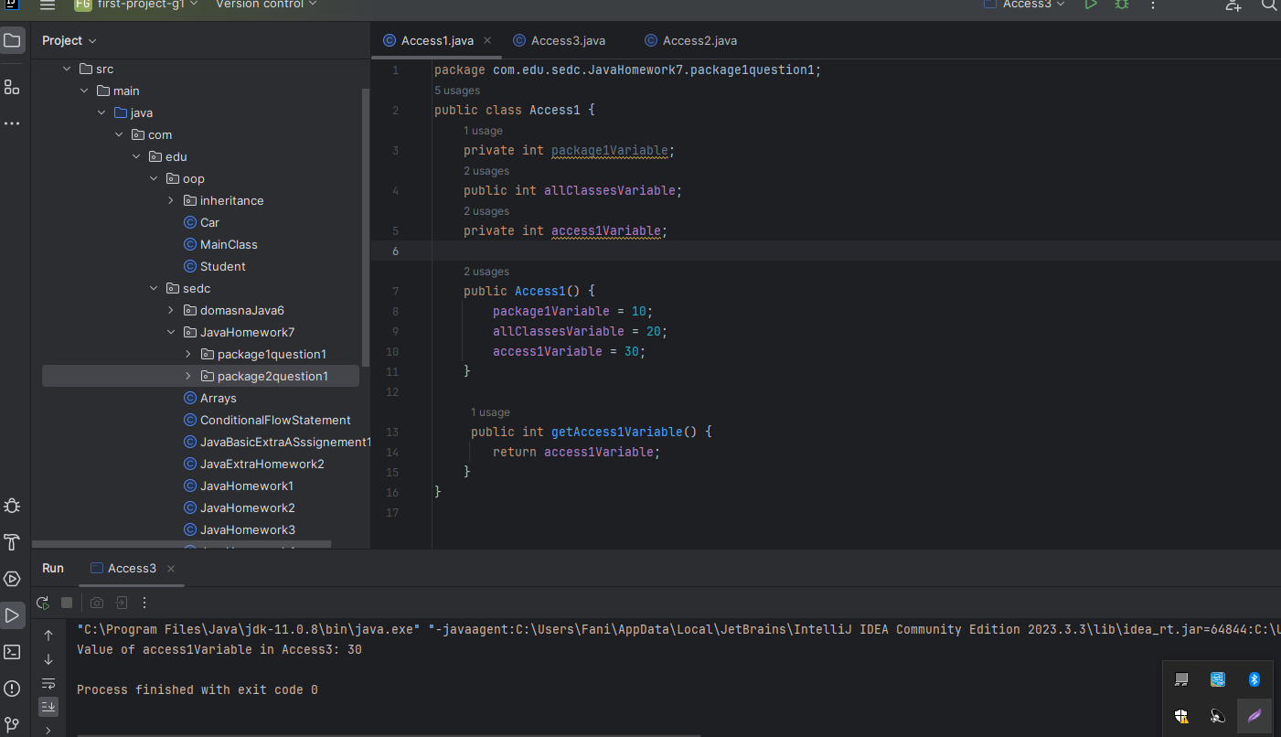

package com.edu.sedc.JavaHomework7.package1question1;  
  
public class Access2 {  
  
 public static void main(String[] args) {  
  
 Access1 access1O = new Access1();  
 System.*out*.println("Value of allClassesVariable: " + access1O.allClassesVariable);  
  
  
 }  
}

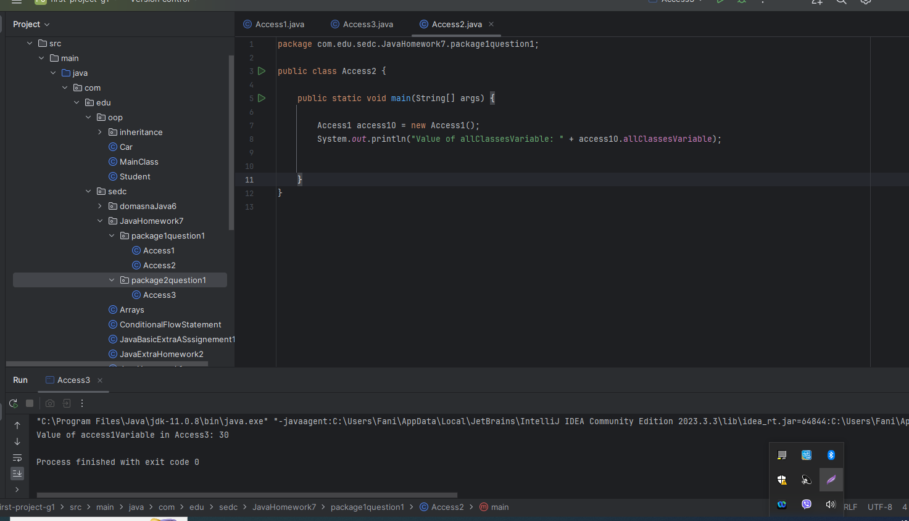

package com.edu.sedc.JavaHomework7.package2question1;  
  
import com.edu.sedc.JavaHomework7.package1question1.Access1;  
  
public class Access3 {  
  
 public static void main(String[] args) {  
 Access1 access10 = new Access1();  
 System.*out*.println("Value of access1Variable in Access3: " + access10.getAccess1Variable());  
 }  
}

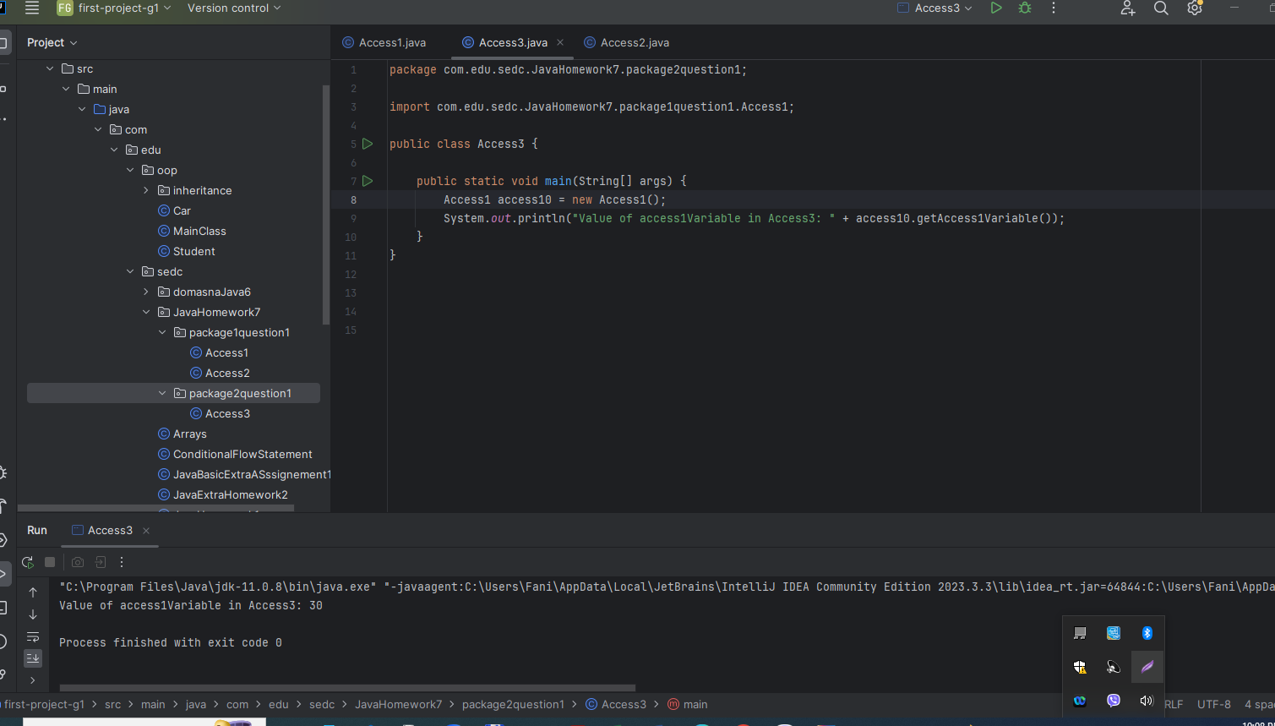

1. Create a class called Calculator.

* Inside the class create 4 methods to perform certain actions:

addMethod (summation of two numbers)

subMethod (subtraction of two numbers)

mulMethod (multiplication of two numbers)

divMethod (division of two numbers)

* Firts two methods, addMethod and subMethod, should be created to not have access by an object of the class.
* Other methods, should be created to have access by an object of the class. (control access level by using correct access modifier)
* Create other class called MainCalculator and create main method.

Under the main method invoke 4 methods created in class calculator.

package com.edu.sedc.JavaHomework7;  
public class Calculator {  
 public static int addMethod(int a, int b) {  
 return a + b;  
 }  
 public static int subMethod(int a, int b) {  
 return a - b;  
 }  
 public int mulMethod(int a, int b) {  
 return a * b;  
 }  
 public double divMethod(int a, int b) {  
 if (b != 0) {  
 return (double) a / b;  
 } else {  
 System.*out*.println("Error: Division by zero!");  
 return Double.*NaN*;  
 }  
 }  
}

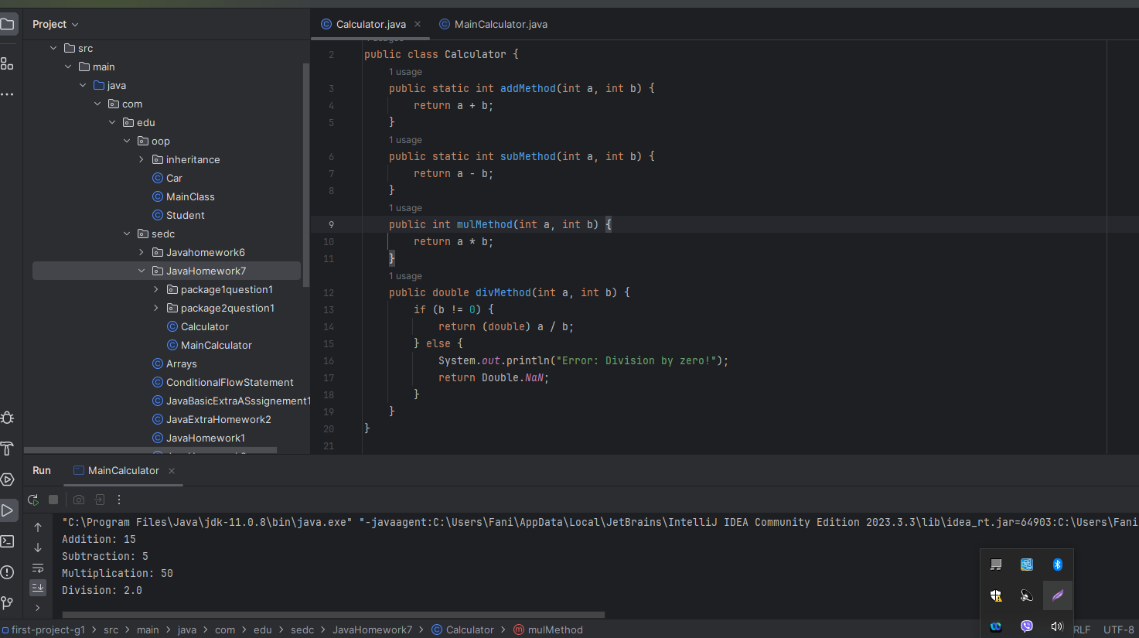

package com.edu.sedc.JavaHomework7;  
  
public class MainCalculator {  
  
 public static void main(String[] args) {  
  
 Calculator calculator = new Calculator();  
  
 int num1 = 10;  
 int num2 = 5;  
  
 System.*out*.println("Addition: " + Calculator.*addMethod*(num1, num2));  
 System.*out*.println("Subtraction: " + Calculator.*subMethod*(num1, num2));  
 System.*out*.println("Multiplication: " + calculator.mulMethod(num1, num2));  
 System.*out*.println("Division: " + calculator.divMethod(num1, num2));  
 }  
  
}

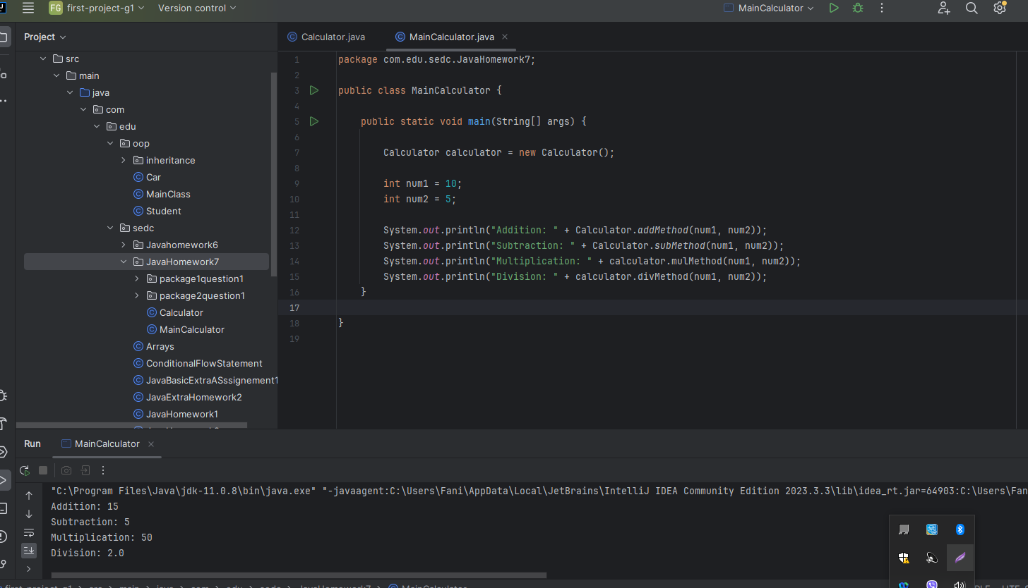

1. Create a class call Shirt.

* Create 2 attributes in the class Shirt:

Create String variable with a name color.

Create another char variable with a name size.

* Create a constructor that will have all 2 attributes as a parameter.
* Create other main class. In the main class, under the main method initialize an object of class Shirt (use created constructor).

Print out, color “Black” and size ‘M’ of shirt.

package com.edu.sedc.JavaHomework7;  
  
public class Shirt {  
 private String color;  
 private char size;  
  
 public Shirt(String color, char size) {  
 this.color = color;  
 this.size = size;  
 }  
 public String getColor() {  
 return color;  
 }  
 public char getSize() {  
 return size;  
 }  
}

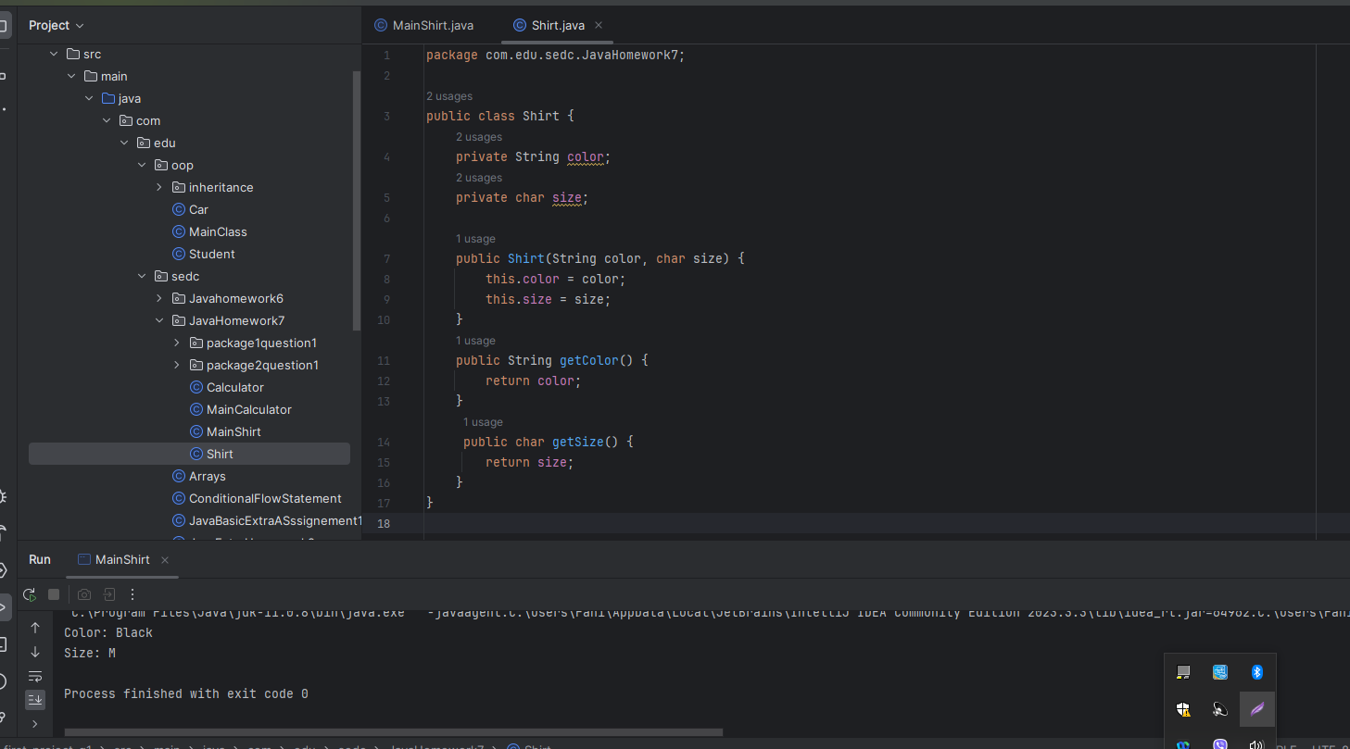

package com.edu.sedc.JavaHomework7;  
  
public class MainShirt {  
  
 public static void main(String[] args) {  
  
 Shirt myShirt = new Shirt("Black", 'M');  
  
 System.*out*.println("Color: " + myShirt.getColor());  
 System.*out*.println("Size: " + myShirt.getSize());  
  
  
 }  
}

